MODULE 5

**1.** Generate a new variable to account for percentage of students responding to the teaching evaluation survey.

    pereval = (students/allstudents)*100

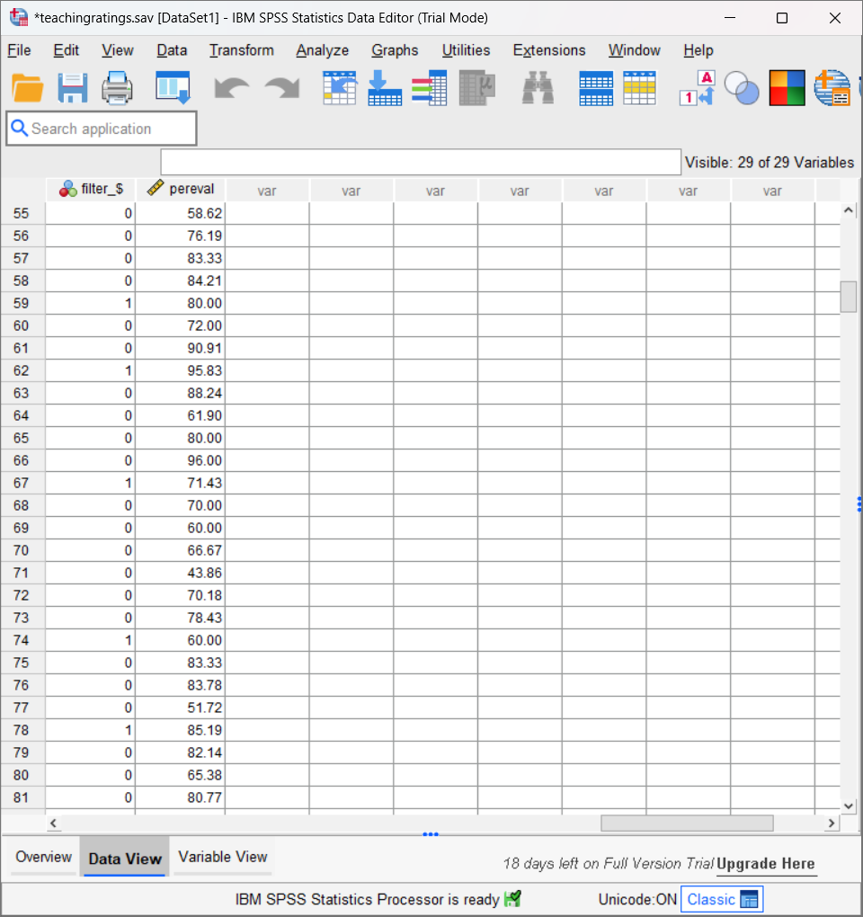

The percentage of students who responded to the teaching evaluation survey for each case.

**2.** Using the weighted data set, find the averages and standard deviations for the following: **eval**, **beauty**, and **age**

|  |  |  |  |
| --- | --- | --- | --- |
| **Descriptive Statistics** | | | |
|  | N | Mean | Std. Deviation |
| beauty | 463 | .0000 | .78865 |
| age | 463 | 48.37 | 9.803 |
| eval | 463 | 3.9983 | .55487 |
| Valid N (listwise) | 463 |  |  |

After Adding the Weighted dataset

|  |  |  |  |
| --- | --- | --- | --- |
| **Descriptive Statistics** | | | |
|  | N | Mean | Std. Deviation |
| beauty | 1851 | .0206 | .79027 |
| age | 1851 | 48.29 | 9.755 |
| eval | 1851 | 4.0751 | .53068 |
| Valid N (listwise) | 1851 |  |  |

**3.** Using the weighted data set, find the averages for the following: **female**, **single_credit**, **upper_division**. Interpret the findings.

|  |  |  |
| --- | --- | --- |
| **Descriptive Statistics** | | |
|  | N | Mean |
| female instructor | 1851 | .4109 |
| upper division course | 1851 | .65 |
| single credit course | 1851 | .07 |
| Valid N (listwise) | 1851 |  |

**4.** Identify the unique records using the variable **prof**, compute the mean and standard deviation for **age** and **beauty**.

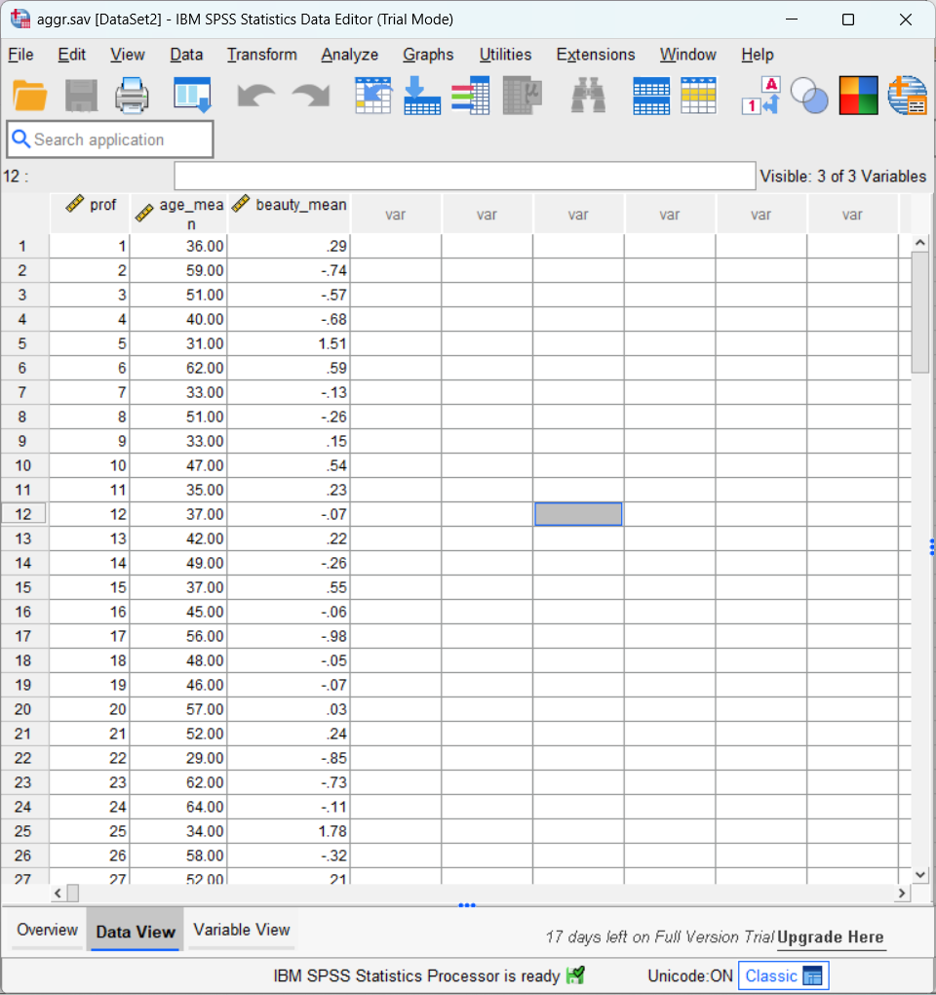

**5.** Using the entire data set, divide the sample into **single_credit** and **more_credit** courses. Repeat steps **2** and **4**.

|  |  |  |  |
| --- | --- | --- | --- |
| **Descriptive Statisticsa** | | | |
|  | N | Mean | Std. Deviation |
| eval | 436 | 3.9658 | .54613 |
| beauty | 436 | .0166 | .79750 |
| age | 436 | 48.43 | 10.071 |
| Valid N (listwise) | 436 |  |  |
| a. credits = more | | | |

|  |  |  |  |
| --- | --- | --- | --- |
| **Descriptive Statisticsa** | | | |
|  | N | Mean | Std. Deviation |
| eval | 27 | 4.5222 | .42184 |
| beauty | 27 | -.2681 | .57584 |
| age | 27 | 47.37 | 3.078 |
| Valid N (listwise) | 27 |  |  |
| a. credits = single | | | |